Project Statement: Our project is a tool that will allow the user to search recent tweets from a list of cities. The tweets will be plotted on a map with markers that hold text and avatars from the tweets. In addition, we will display recent news articles from that city, perform sentiment analysis on the tweets, and display a plot of followers for the gathered tweets. This tool can be used to gather news from a region and easily get a sense of what is going on and how people are reacting.

Link to a dataset we are using for testing:

-Data sets will be created whenever the tool is run.

Carto/Leaflet/Mapbox Map

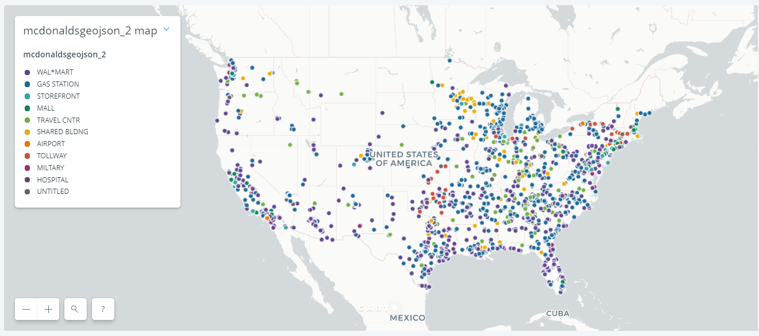

Plotly Graph

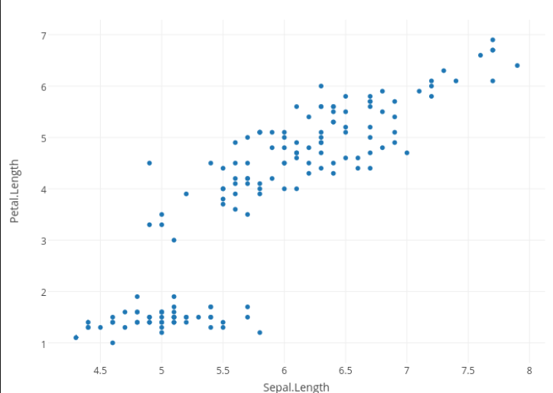

Javascript Meter

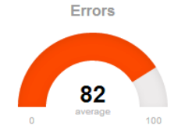

The sketch for our design will can be found on our github in the file named “project process flow.png” in the py scripts (record keeping folder): [link_to_github](https://github.com/jo2232/Data_Boot_Project_2)